Event Grid

Event sources

- Azure App Configuration
- Azure Blob Storage
- Azure Communication Services
- Azure Container Registry
- Azure Event Hubs
- Azure IoT Hub
- Azure Key Vault
- Azure Machine Learning
- Azure Maps
- Azure Media Services
- Azure Policy
- Azure resource groups
- Azure Service Bus
- Azure SignalR
- Azure subscriptions
- Azure Cache for Redis
- Azure Kubernetes Service (preview)

Event handlers

- Azure Automation
- Azure Functions
- Event Hubs
- Relay Hybrid Connections
- Logic Apps
- Power Automate (Formerly known as Microsoft Flow)
- Service Bus
- Queue Storage
- WebHooks

Concepts
There are five concepts in Azure Event Grid that let you get going:
- Events - What happened.
- Event sources - Where the event took place.
- Topics - The endpoint where publishers send events.
- Event subscriptions - The endpoint or built-in mechanism to route events, sometimes to more than one handler. Subscriptions are also used by handlers to intelligently filter incoming events.
- Event handlers - The app or service reacting to the event.

Event Grid, Event Hubs, and Service Bus
Azure offers three services that assist with delivering events or messages throughout a solution. These services are:
- Azure Event Grid
- Azure Event Hubs
- Azure Service Bus
Although they have some similarities, each service is designed for particular scenarios. This article describes the differences between these services, and helps you understand which one to choose for your application. In many cases, the messaging services are complementary and can be used together.

Event
An event is a lightweight notification of a condition or a state change. The publisher of the event has no expectation about how the event is handled. The consumer of the event decides what to do with the notification. Events can be discrete units or part of a series.

Message
A message is raw data produced by a service to be consumed or stored elsewhere. The message contains the data that triggered the message pipeline. The publisher of the message has an expectation about how the consumer handles the message. A contract exists between the two sides. For example, the publisher sends a message with the raw data, and expects the consumer to create a file from that data and send a response when the work is done.

Azure Event Grid
Event Grid is an eventing backplane that enables event-driven, reactive programming. It uses the publish-subscribe model. Publishers emit events, but have no expectation about how the events are handled. Subscribers decide on which events they want to handle.

Azure Event Hubs
Azure Event Hubs is a big data streaming platform and event ingestion service. It can receive and process millions of events per second. It facilitates the capture, retention, and replay of telemetry and event stream data. The data can come from many concurrent sources. Event Hubs allows telemetry and event data to be made available to various stream-processing infrastructures and analytics services

Azure Service Bus
Service Bus is a fully managed enterprise message broker with message queues and publish-subscribe topics. The service is intended for enterprise applications that require transactions, ordering, duplicate detection, and instantaneous consistency.

Use the services together
In some cases, you use the services side by side to fulfill distinct roles. For example, an e-commerce site can use Service Bus to process the order, Event Hubs to capture site telemetry, and Event Grid to respond to events like an item was shipped.
Creating events subscriptions for storage account
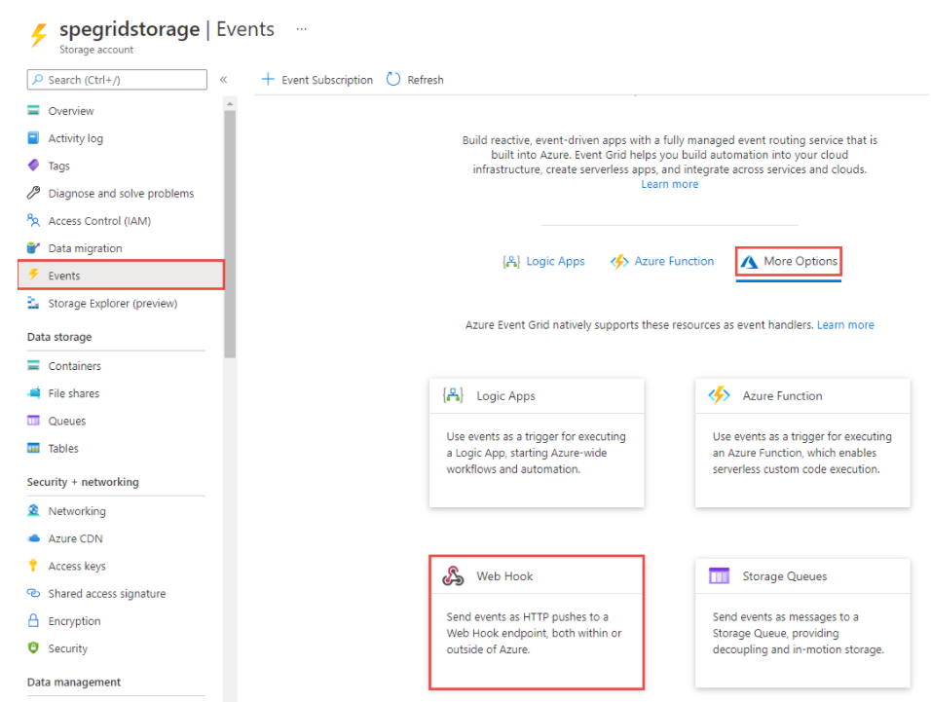
Enable event grid resource provider
az provider register --namespace Microsoft.EventGrid
az eventgrid event-subscription create \
--source-resource-id $storageid \
--name <event_subscription_name> \
--endpoint $endpoint

az storage blob upload --file testfile.txt --container-name testcontainer --name testfile.txt

Custom topic

az eventgrid topic create --name $topicname -l westus2 -g gridResourceGroup

az eventgrid event-subscription create \
--source-resource-id "/subscriptions/{subscription-id}/resourceGroups/{resource-group}/providers/Microsoft.EventGrid/topics/$topicname" \
--name demoViewerSub \
--endpoint $endpoint

Event Grid Trigger Function

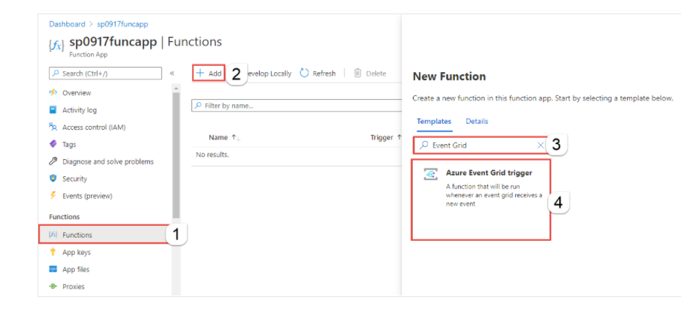

Create a container registry
az acr create --resource-group $RESOURCE_GROUP_NAME --name $ACR_NAME --sku Basic

Azure Event Hubs
  - Big data event streaming service
  - Scalable up to terabyes of data and millions of events per second
  - Reliable with zero data loss (agnostic to failures)
  - Supports multiple protocols and SDKs
Scenarios for Vent Hubs
Anomaly detection (fraud/outliers)
Application logging
Analytics pipeline , such as clickstreams
Live dashboarding
Archiving data
Transaction processing
User telemetry processing
Device telemetry streaming

Event producers send events via AMQP (Advanced Messaging Queuing Protocol) , HTTP or Apache Kafka

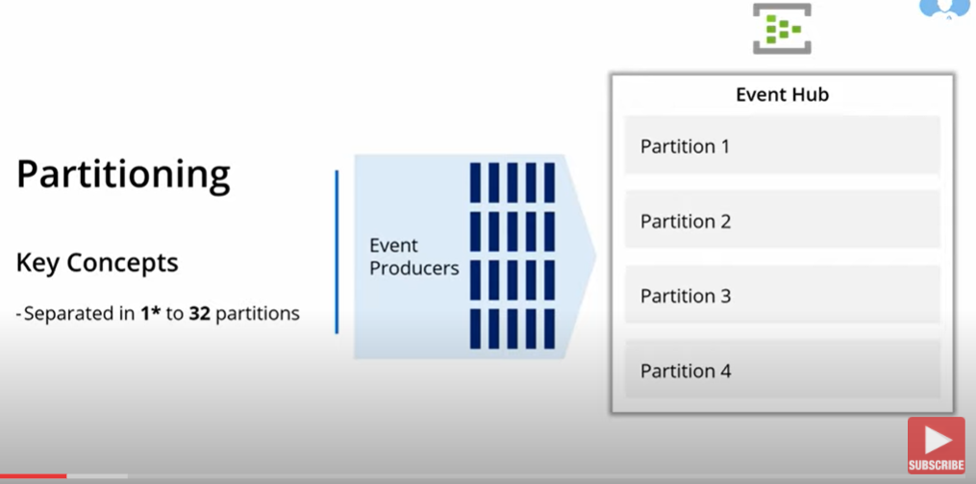

Load balanced distribution
Each partition is ordered
Partition Key allows for ordered processing

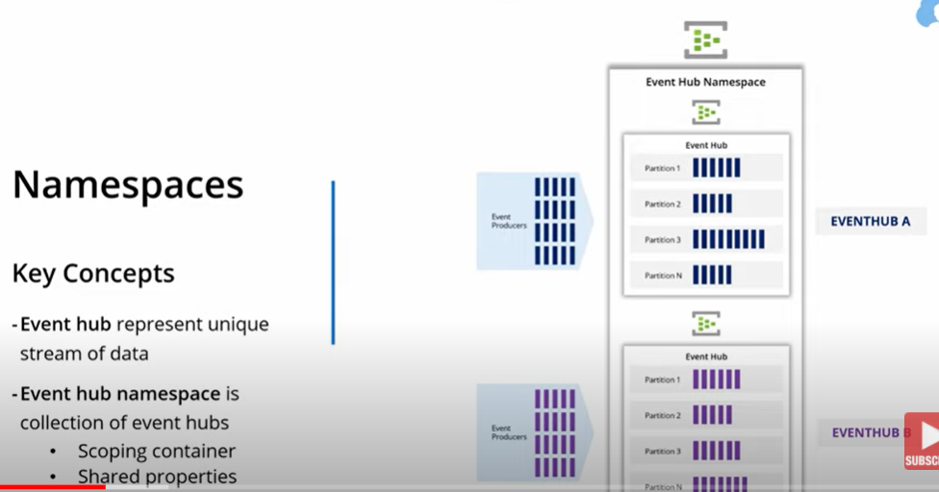
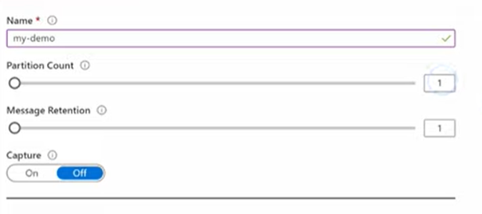
Using Azure.Messaging.EventHubs
Using Azure.Messaging.EventHubs.Producer

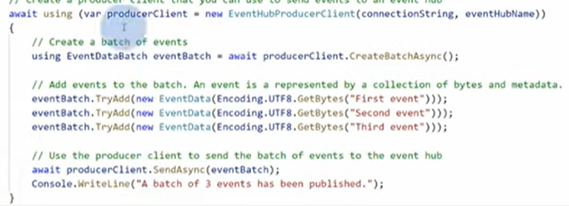
Send event to hub via logic app
Event Consumers
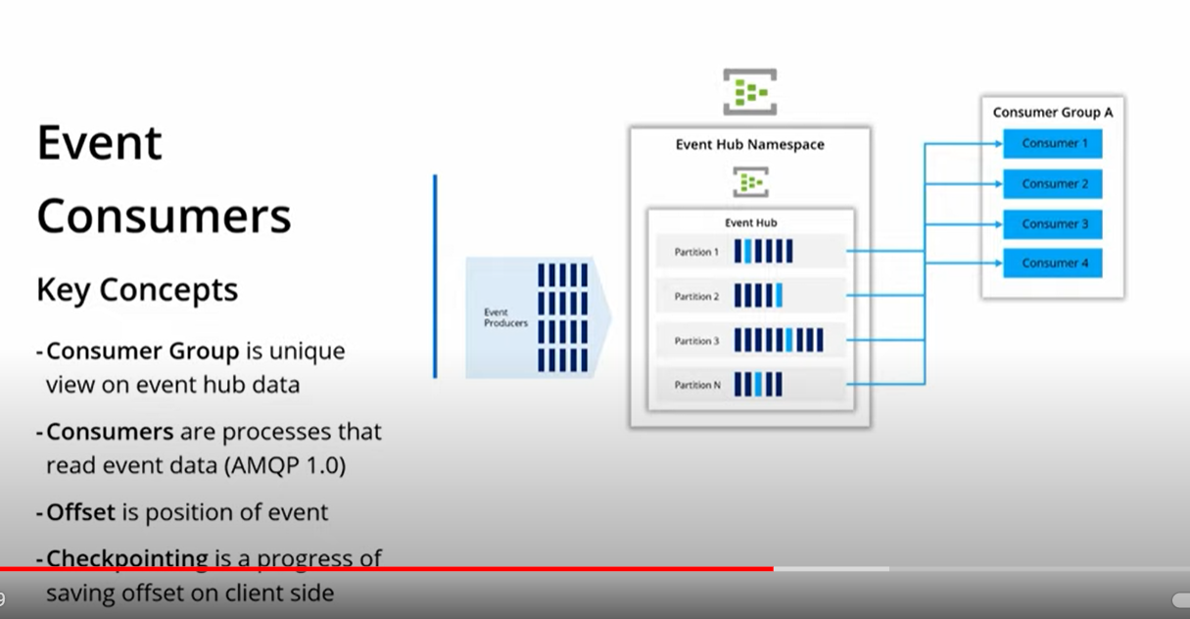
Checkpointing is done , so that we start from where we left . It is handled to client level and stored in azure storage.
Configuring consumer groups in Event Hubs
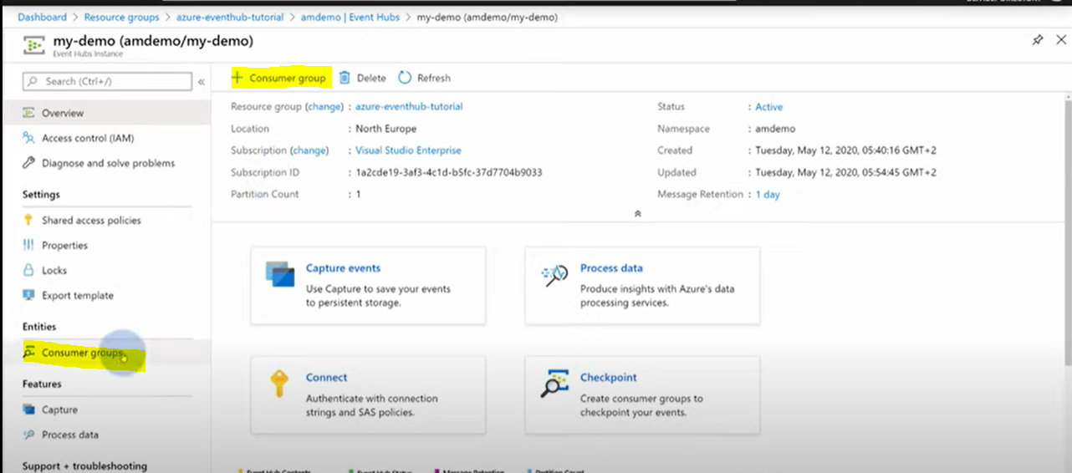
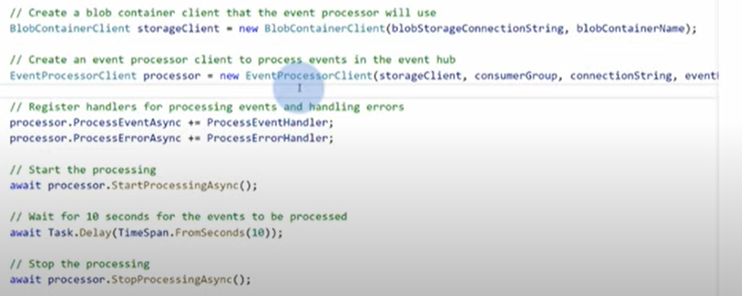
Azure Event Hubs capture eanbls you to automatically deliver the straming data in Event Hubs to an Azure Blob Storage
Auto scaling with Auto-inflate
Geo-disaster recovery via geo-replication with region pairing
Azure Service Bus
Queues , Topic
Queues and Topics can have there own shared access policies , listener or sender
Microsoft.Azure.ServiceBus

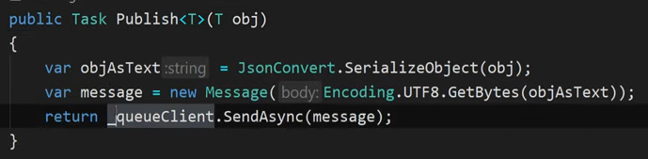
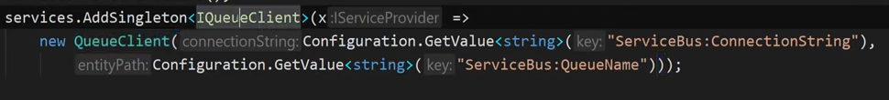

Service Bus Explorer

For Topic we have to create Subscription

ITopicClient TopicClient
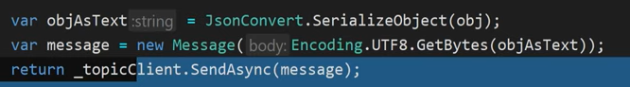
Add filter to the subscription SQL Filter & Corelation Filter (Example : messageType is Order)

